Practical 1 IT
Kartikey Sharma
CSC/21/18

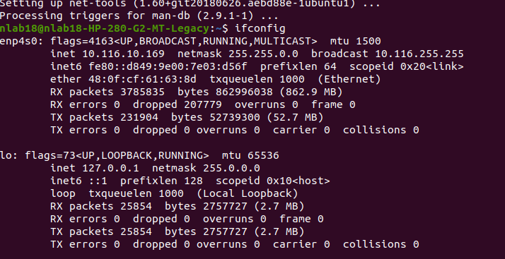
Ipv4 address – 10.116.10.169(class A)
Subnet mask – 255.0.0.0
Broadcast address – 10.116.255.255

Fo class A :
Total networks = 2^7 = 128
Total hosts for each networks : 2^24 – 2 = 16777214

for this network :
Network Address : (subnet mask ) and (ip) = 10.0.0.0
Range of IP addresses for hosts = 10.0.0.0 -

